Percentile-Assignment

Output Report

Dataset: Placement.csv

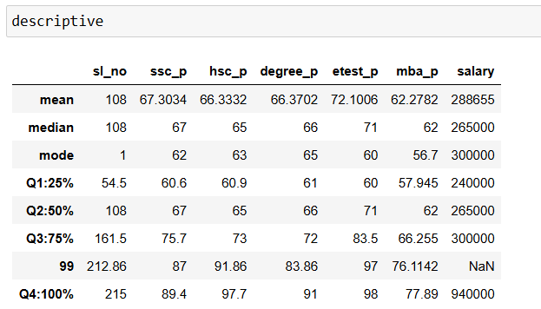

Observation:

For SSC Mark ,25% of the data ranges upto 60.6

50% of the data ranges upto 67 with 7% increase from q1

75% of the data ranges upto 75.7 with 8% increase from previous q2(50%)

99% of the data ranges upto 87 with 13% increase from Q3

(100%)Overall the data ranges upto 89.4

For HSC mark, 25% of the data ranges upto 60.9

50% of the data ranges upto 65 with 5% increase from the previous q1

75% of the data ranges upto 73 with 8%increase from q2

99% of the data ranges upto 91.86 with 18% increase from q3

Overall the dataranges upto 97.7

For degree mark, 25% of the data ranges upto 61

50% of the data ranges upto 66 with 5% increase from the previous q1

75% of the data ranges upto 72 with 6%increase from q2

99% of the data ranges upto 83.86 with 11% increase from q3

Overall the dataranges upto 91